Student GrantMatch
Team & Group: G4, GardenStateAI
Atishay Jain, Dinesh Chandramohan | atishay23@gmail.com, dineshcm01@gmail.com
Repo: https://github.com/atishaydottech/Capstone-Project | Approach: Agentic RAG with Pydantic AI
Contents
1. Problem Statement & Goals 2. Architecture 3. Tool Stack 4. Evaluation Criteria 5. MVP Scope

1. Problem Statement & Goals
Students often don't know which scholarships or grants they actually qualify for. Rules are scattered across long documents, and keyword search misses matches or gives wrong ones. This tool takes a student's basic info and tells them which programs they qualify for, citing the exact rule that says so.
Goals
- Check a student's info (income, state, GPA, major, etc.) against real program rules.
- Show the exact rule behind each yes or no, not just an answer.
- Flag partial matches instead of forcing a plain yes or no.
- Search documents only when needed, not on every query.
- Test against labeled profiles and measure real accuracy.
- Report eligibility only — not odds of winning.

2. Architecture
Two phases. Offline, program rule documents are chunked, embedded, and loaded into ChromaDB once. At runtime, a Pydantic AI ReAct agent takes the student's query, decides whether to call the retriever tool (vector search over the rule chunks) or the web search tool, observes the result, loops if it needs more, and returns a structured answer citing the exact clause it relied on.

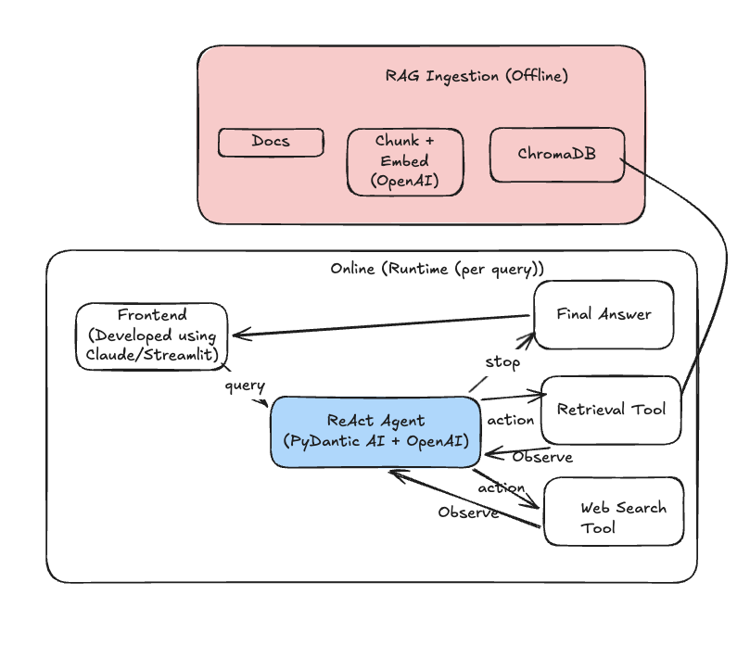

3. Tool Stack
- Pydantic AI: agent loop and tool-calling (Thought / Action / Observation), plus structured, validated outputs.
- OpenAI API: LLM for reasoning + embeddings (text-embedding-3-small).
- ChromaDB: local vector store for retrieved chunks.
- Retriever tool: wraps the vector store as a callable agent tool.
- Web search tool (Tavily / SerpAPI): second tool, gives the agent a real choice.
- Tracing: logs tool calls and latency for evaluation.
- Streamlit or Claude-made UI: simple front end for the demo.
Framework reasoning: Pydantic AI provides the ReAct-style loop needed here without a second framework on top, and its structured output format (a typed schema for eligibility + cited clause) directly supports precision and citation-accuracy scoring — avoiding fragile parsing of free-form text.

4. Evaluation Criteria
Quantitative
- Eligibility accuracy vs. 25–30 hand-labeled student profiles.
- Citation accuracy: correct rule quoted, not just a correct answer.
- Hallucination rate: cited details not actually in the source.
- Tool-call count and response latency per query.
- Consistency across repeated identical queries.
- Targets: >80% eligibility accuracy, >70% citation accuracy, <10% hallucination rate.
Qualitative
- Rate cited rules as correct, close, or unrelated on a sample.
- Review worst-performing cases and tag the failure cause.
- Check answers are understandable without reading the source document.
- Check tone is neutral and appropriately cautious on uncertain cases.
- Manually review borderline/edge-case profiles for nuance.

5. MVP Scope — Codebase Reuse
3–4 day build. Two existing lab repos already contain the pieces this project needs — the plan is to adapt them, not start from zero.
Reusing existing code
- Chunking + vector store: rag-chunking-lab/chunking (recursive or section-wise) and vectordb/chroma_store.py, reused directly for ingestion; swap the embedder for OpenAI text-embedding-3-small per the tool stack above.
- Baseline RAG: rag-chunking-lab/rag/pipeline.py as the starting point for the required vanilla retrieve-then-answer baseline.
- Agent loop: single-agent-lab/agent.py — the Pydantic AI Agent + tool_plain pattern, adapted from its TravelBriefing / NeedMoreInfo output union to an EligibilityAnswer / NeedMoreInfo schema with a cited-clause field.
- Web search tool: single-agent-lab/tools/web_search.py reused as-is for the agent's second tool.
- Tracing: single-agent-lab/trace.py pattern reused for tool-call and latency logging.
MVP scope (in for v1)
- 10–15 programs with clear, checkable rules; retriever + web search tools; structured eligibility answer with cited clause; baseline-vs-agent comparison; 25–30 profile eval set; Streamlit UI.
Deferred past MVP
- Hybrid/BM25 search, reranking, query rewriting, multi-turn memory, UI polish — correctness first, cosmetics later.
Build order
- Day 1: adapt ingestion on 10–15 programs; get the vanilla RAG baseline answering test queries.
- Day 2: adapt the agent pattern with both tools and the typed eligibility output; wire tracing.
- Day 3: build the eval set, run baseline-vs-agent comparison, finish the UI, write up results and record the demo.
Project To-Do List

Design & Approval
- Finalize one-pager design doc (problem, architecture, evaluation criteria, framework justification), due July 12
- Submit design doc via the submission form to unlock OpenAI API key

Data & Ingestion
- Pick 10-15 scholarship/grant programs with clear, checkable eligibility rules
- Collect the public rule documents (PDFs/web pages)
- Chunk, embed, and load into ChromaDB

Baseline First
- Build a vanilla RAG baseline (single retrieve-then-answer, no agent loop) before adding agent complexity
- Run test queries against the baseline to confirm ingestion and retrieval work

Agent Build
- Build the ReAct agent (Pydantic AI) with the retriever tool
- Add the second tool (web search) so the agent has a real decision to make
- Add tracing/logging for tool calls and latency

Comparative Evaluation (required)
- Run the same test queries through both the vanilla RAG baseline and the agentic version
- Compare results on accuracy, citation accuracy, and hallucination rate between the two
- Write a short justified conclusion on which approach wins and why

Test Set & Metrics
- Build 25-30 hand-labeled synthetic student profiles with manually-verified ground truth
- Run full evaluation: eligibility accuracy, citation accuracy, hallucination rate, tool-call efficiency, latency
- Do the qualitative review: clause relevance scoring, failure mode log, explanation clarity check

Failure Analysis (required for README)
- Keep a running log of approaches tried, what failed, and why, as you build
- Write the README section documenting attempted approaches and pivots

UI
- Build the Streamlit interface

Final Deliverables
- Trim design doc to 1-2 pages
- Write full documentation, max 4-5 pages
- Make sure code repo is accessible for review
- Record a 3-minute demo video walkthrough
- Submit everything by July 22

